Empowering Educators with Problem-Based Learning: Unlocking the Potential of Generative AI in Secondary Education

Jeremy Nevitt

A thesis submitted in partial fulfillment
of the requirements for the degree of
Master of Arts in Instructional Technology
Stockton University

Written under the direction of
Jung Lee

And approved by:

____________________________________
Jung Lee, Ph.D.
Professor of Instructional Technology
Advisor

April 8, 2025

Abstract
This capstone project addresses the instructional challenge faced by secondary educators who struggle to balance routine non-instructional tasks, such as grading, lesson planning, and administrative duties, with their primary goal of engaging students and delivering personalized instruction. Research highlights a gap in educators’ effective utilization of generative artificial intelligence (AI) tools, largely due to limited awareness, training, or confidence in adopting these technologies.
To bridge this gap, the project implemented a professional development program grounded in Problem-Based Learning (PBL). This approach empowered teachers to collaboratively engage with AI tools like ChatGPT, MagicSchool.ai, Gradescope, and Canva by solving authentic, classroom-related challenges. The theoretical framework emphasized active learning, collaboration, and reflective practices, fostering practical application and confidence among participants.
The Intervention consisted of five targeted sessions, each focusing on a distinct aspect of educators' daily responsibilities, progressively building teachers’ familiarity and competence with generative AI tools. Teachers experienced hands-on activities tailored to their subject-specific needs, practiced creating differentiated instructional resources, streamlined administrative tasks, and explored sustainable AI integration strategies. This structured, scaffolded program aimed not only to enhance instructional efficiency but also to transform teachers’ perceptions of AI from intimidating technology to essential tools for innovation and improved student engagement.
Table of Contents
Chapter 1: Introduction 4
Instructional Problem 4
Introduction 4
Theoretical Framework 5
Conclusion 5
Needs Analysis 6
Focus Group Overview and Findings 7
Conclusion 8
Goals, Objectives, and Research Questions Used 9
Goals 9
Objective 9
Research Questions 10
Chapter 2: Literature Review 11
Introduction 11
Bridging the Gap Between AI’s Potential and Practical Implementation in Education 11
Problem-Based Learning (PBL) 13
Using Problem-Based Learning to Facilitate AI Integration 14
Conclusion 15
Chapter 3: Project Design 16
Procedural Design 16
Lesson 1: Automating Grading and Feedback 17
Lesson 2: Streamlining Lesson Planning and Resource Generation 19
Lesson 3: Developing Personalized Learning Materials for Differentiated Instruction 21
Lesson 4: Facilitating Parent Communication and Administrative Tasks 23
Lesson 5: Reflective Practices and Sustainable AI Integration 25
Sufficiency of Five Lessons 27
Chapter 4: Evaluation 29
First Evaluation 29
Second Evaluation 30
Second Evaluation Results 31
Chapter 5: Discussion and Conclusion 33
Summary of the Study 33
Discussion 33
Limitations of the Study 34
Implications for Future Research and Practice 35
Appendix A. 39
Appendix B. 41
Post-Intervention Survey 41
General Survey Questions 41
Subject-Specific Questions 43
Appendix C. 45
Appendix D. 50
Survey on the Effectiveness of the Intervention 50
Survey Questions 50
Appendix E. 52

Table of Figures
Figure 1 Objectives for Lesson 1 18
Figure 2 Independent Practice for Lesson 1 19
Figure 3 Objectives for Lesson 2 20
Figure 4 Independent Practice for Lesson 2 21
Figure 5 Objectives for Lesson 3 22
Figure 6 Independent Practice for Lesson 3 23
Figure 7 Objectives for Lesson 4 24
Figure 8 Independent Practice for Lesson 4 25
Figure 9 Objectives for Lesson 5 26
Figure 10 Independent Practice for Lesson 5 27

Chapter 1: Introduction

Instructional Problem

Introduction
The primary goal of education will always be to engage students and improve learning outcomes. As schools increasingly emphasize personalized instruction, teachers often find it challenging to balance these evolving demands with the repetitive nature of their daily responsibilities. My capstone project examined the issue of secondary school teachers not effectively utilizing generative artificial intelligence (AI) tools to manage routine, non-instructional tasks like lesson planning, creating educational resources, and handling administrative work. These time-consuming responsibilities frequently divert attention away from direct instruction and meaningful student engagement.
The concept of leveraging generative AI to alleviate these burdens emerged from growing research on AI’s potential in education. While tools like ChatGPT and similar systems showed promise in content creation, a significant gap remained in educators’ ability to integrate these technologies effectively. Many teachers lacked awareness, training, or confidence in applying AI in practical, instructional contexts. My project aimed to bridge this gap by developing and implementing professional development sessions using problem-based learning (PBL). This approach empowered educators to incorporate AI into their daily routines, ultimately enhancing efficiency and improving the overall educational experience.

Theoretical Framework
Implementing PBL in professional development sessions enabled teachers to engage actively with AI tools by addressing real-world, education-related challenges. Rather than passively receiving information, teachers explored AI-driven solutions such as ChatGPT, MagicSchool.ai, and other platforms. PBL’s collaborative nature encouraged educators to work in teams, exchange insights, and develop best practices for effective AI integration. This interactive model fostered both confidence and motivation (Hmelo-Silver, 2004; Thorndahl & Stentoft, 2020).
Reflection, a fundamental component of PBL, allowed teachers to critically assess the effectiveness of AI tools and refine their approach to sustainable implementation. Savery (2015) emphasized that this method mirrors real-world problem-solving, helping teachers connect AI capabilities to practical classroom applications. By collaboratively working through complex scenarios, educators gained a deeper understanding of AI’s potential to minimize routine workload, freeing them to concentrate on dynamic, student-centered teaching.
The ultimate objective was to shift teachers’ perceptions of AI from an intimidating, unfamiliar technology to a valuable, indispensable resource for educational innovation. Professional development grounded in PBL encouraged lifelong learning and problem-solving skills, ensuring that educators remained adaptable in an evolving educational landscape (Thorndahl & Stentoft, 2020).

Conclusion
In summary, integrating PBL into professional development provided a robust framework for equipping teachers with the necessary skills and confidence to effectively implement generative AI tools. Through collaborative problem-solving and reflective exercises, educators not only gained hands-on experience with AI technologies but also developed sustainable strategies for optimizing workflow. This approach ensured that teachers could dedicate more time to student-centered instruction, ultimately improving both teaching quality and learning outcomes. By transforming AI from an abstract concept into a practical, instructional asset, educators embraced innovation, fostering adaptability and continuous growth in an ever-changing educational environment.

Needs Analysis
The primary purpose of the needs analysis was to evaluate the level of understanding, utilization, and perceptions of generative AI tools among secondary education teachers, with the goal of identifying specific educational and support needs that could facilitate the integration of AI technologies into routine educational tasks. By gathering data from a diverse group of educators, the assessment pinpointed key challenges and barriers that teachers faced in adopting AI tools, as well as their potential readiness and interest in professional development opportunities related to AI. The insights gained from this analysis were instrumental in designing targeted professional development programs that addressed these gaps and leveraged AI's capabilities to enhance teaching effectiveness and efficiency.
A focus group was conducted with 30 secondary education teachers to assess their experiences and perspectives regarding the use of generative AI tools for completing routine, mundane tasks. The focus group was asked a series of questions designed to gather in-depth insights into their experiences and attitudes toward AI tools. These questions explored their familiarity with specific AI technologies and their potential applications in educational settings. Participants described how much time they spent on routine tasks and whether they believed AI could effectively reduce this burden. They also shared their confidence levels in using AI tools for these tasks and the perceived barriers—such as technological familiarity or resistance to change—that might hinder their adoption. Finally, participants identified the types of support or resources that would help them feel more comfortable and confident in utilizing AI technologies in their classrooms. These questions uncovered both the practical and psychological factors that influenced the adoption of AI in educational contexts, providing a comprehensive understanding of where support was most needed.

Focus Group Overview and Findings
For the first question, "Familiarity with AI Tools," results indicated that a significant number of teachers were not very familiar with generative AI tools. Sixty percent of participants reported only moderate or lower levels of familiarity, suggesting a foundational gap in understanding the potential applications of AI in education.
In response to the second question, "Time Spent on Mundane Tasks," teachers reported dedicating significant hours each week to these routine tasks. The average time spent on lesson planning, creating instructional materials, and administrative duties was 12.5 hours per week, accounting for approximately 31.25% of the workweek. The data suggested that AI could significantly reduce this time, potentially enhancing teaching effectiveness and job satisfaction.
For the third question, "Confidence in Using AI," responses showed varied confidence levels, with 36.7% of participants feeling only moderately confident about using AI tools. This indicated a strong need for professional development programs that enhanced teachers' confidence and competence in utilizing AI technologies.
Participants identified resistance to new technologies, lack of time, and doubts about the usefulness of AI tools as the main obstacles preventing them from integrating AI in response to the fourth question, "Perceived Barriers." These barriers suggested that teachers hesitated to adopt AI due to fears about its complexity, effectiveness, or the time investment required to learn new technologies. Addressing these concerns through targeted training and demonstrations was identified as a key strategy for encouraging adoption.
In response to the fifth question, "Interest in Professional Development," more than half of the respondents (56%) expressed moderate to very high interest in AI-focused professional development. This highlighted an openness to learning and integrating new technologies if appropriate support was provided.
Finally, in the sixth and seventh questions, "Potential AI Integration and Support Needs," teachers proposed several potential uses for AI, including automated feedback systems and streamlining administrative tasks like email creation. However, they also emphasized the need for support mechanisms such as training workshops, instructional guides, and peer mentoring to facilitate effective integration. While there was strong interest in AI adoption, there was also a clear need for ongoing support and practical resources that helped educators integrate AI into their daily routines.

Conclusion
The findings from the needs analysis aligned closely with the overarching goal of my capstone project: leveraging generative AI to alleviate secondary educators from time-consuming, mundane tasks, thereby enhancing their capacity to focus more on instruction and student interaction. The focus group's insights affirmed the necessity for structured professional development that educated teachers about AI's benefits and practical applications, particularly in automating routine educational tasks.
This analysis showed that teachers spent over 30% of their workweek on tasks that AI could streamline, highlighting AI’s potential to significantly enhance teaching effectiveness. Given that 56% of respondents expressed interest in AI-focused professional development, a strategic professional development approach was crucial in facilitating successful AI adoption. By providing educators with the skills and resources needed to integrate AI into their daily workflows, the program aimed to improve educational outcomes and allow teachers to devote more time to personalized instruction and student engagement.

Goals, Objectives, and Research Questions Used

Goals
The goal of my capstone project was:
To equip educators with the skills, confidence, and strategies to effectively integrate generative AI tools, reducing non-instructional workload, enhancing instructional quality, fostering collaboration, and promoting sustainable practices to improve student engagement and personalized learning.

Objective
Through the implementation of instructional interventions using AI tools and problem-based learning (PBL) strategies, teachers would:
- Use generative AI tools (e.g., ChatGPT, magicschool.ai) at least twice weekly to automate grading, lesson planning, or other non-instructional tasks, with usage tracked through platform logs.
- Identify and document five routine classroom tasks where AI can be applied to improve efficiency, with task identification verified through lesson plan submissions.
- Reflect on their experiences with AI tools weekly through structured journaling or surveys, with the reflection data analyzed to identify changes in perceptions and practices.

Research Questions
- To what extent does the use of generative AI tools through PBL reduce teachers’ non-instructional workload?
- How does participation in PBL based collaborative workshops affect teachers' confidence in using AI tools?
- In what ways do AI tools enhance personalized learning?

Chapter 2: Literature Review

Introduction
Advances in generative AI offer significant opportunities to improve education by reducing teachers' administrative burdens and enhancing instructional practices. Tasks such as grading, lesson planning, and resource management can be automated, freeing educators to focus on student engagement and meaningful instruction. However, a critical gap existed between the potential of AI tools and their practical implementation by teachers. Many educators face challenges related to technical expertise, lack of awareness, and insufficient training, which limited the effective use of AI in classrooms.
Without adequate preparation, teachers struggle to use AI effectively, risking diminished instructional quality or missed opportunities to enhance personalized learning. PBL provided a solution by immersing educators in real-world challenges, allowing them to explore AI tools in meaningful ways. Through hands-on experience, collaboration, and reflection, PBL provided the framework necessary to equip teachers with the skills and confidence to adopt AI sustainably. This literature review explored how the thoughtful integration of AI, supported by PBL strategies, helped empower educators to balance their responsibilities, prevent burnout, and enhance student learning outcomes.

Bridging the Gap Between AI’s Potential and Practical Implementation in Education
The instructional challenge laid in the gap between the potential of AI tools and their practical adoption by educators. Bridging this gap was essential for reducing teachers’ workloads, allowing them to prioritize student engagement and meaningful instruction. While AI has the capacity to streamline tasks, educators often lacked the training and confidence to fully utilize these technologies. Addressing this problem ensured teachers could leverage AI tools to enhance their teaching practices and improve learning outcomes.
Koukopoulos and Koukopoulos (2020) emphasized that AI tools could automate administrative tasks, freeing up teachers’ time for student-centered activities. However, they cautioned that proper training was essential for teachers to harness AI effectively. Without targeted professional development, educators missed opportunities to increase efficiency and instructional quality. Similarly, Hammond (2020) warned that poorly implemented AI could compromise the integrity of instruction. Teachers need clear guidelines to ensure AI supported meaningful learning outcomes rather than functioning as a shortcut.
Kaplan-Rakowski et al. (2023) found that teachers who frequently used generative AI tools, like ChatGPT, developed more positive attitudes toward them. However, adoption remained slow due to limited awareness and technical expertise. Collaborative professional development helped overcome these initial barriers, fostering confidence and enabling teachers to integrate AI effectively. AI, when thoughtfully applied, empowered teachers to meet diverse student needs through personalized learning, enhancing both classroom management and instructional delivery (Luckin et al., 2016).
Hashem et al. (2024) highlighted AI’s potential to alleviate teacher burnout by automating time-consuming tasks such as lesson planning and grading. They argued that effective AI use fostered a sustainable teaching environment by reducing non-instructional burdens. However, as Luckin et al. (2016) cautioned, AI had to complement rather than replace teachers. Thoughtful integration allowed educators to reclaim time for student engagement while ensuring instructional quality was maintained.

Problem-Based Learning (PBL)
PBL is an instructional approach that emphasizes student-centered learning through real-world problem-solving. According to Savery (2015), PBL distinguishes itself from other teaching methods by placing learners in active roles where they take responsibility for identifying and solving complex problems, with instructors acting as facilitators rather than direct sources of knowledge. This approach fosters critical thinking, collaboration, and independent learning as students engage in inquiry-driven processes to develop viable solutions. Rather than passively receiving information, learners in PBL environments explore challenges that connect directly to real-world scenarios, making the learning experience more meaningful and relevant.
Hmelo-Silver (2004) explained that PBL encourages “self-directed learning” by allowing students to synthesize knowledge from multiple domains and apply it to authentic tasks. PBL frameworks often require students to work through open-ended problems that mimic real-life challenges, promoting new ways of thinking and skills such as planning, self-monitoring, and reflecting on their progress. This approach supports knowledge retention and deeper understanding by helping students construct connections between various concepts. Through PBL, learners develop essential skills, including problem-solving, critical thinking, and collaboration—all abilities necessary for lifelong learning and effective participation in professional environments.
Thorndahl and Stentoft (2020) emphasized that reflection is a critical element of PBL, ensuring that students think deeply about their experiences, evaluated their solutions, and refined their approaches. PBL also promotes teamwork by encouraging learners to collaborate, share insights, and leverage each other’s strengths to address challenges. This collaborative process nurtures interpersonal skills, preparing students to work effectively in group settings. The open-ended nature of PBL makes it adaptable to a variety of educational contexts, providing students with opportunities to learn how to navigate uncertainty and ambiguity. By fostering both individual responsibility and teamwork, PBL equipped learners with the tools needed to thrive in dynamic, real-world environments.

Using Problem-Based Learning to Facilitate AI Integration
PBL provided an ideal framework for helping educators explore the practical use of generative AI tools. Through real-world challenges such as automating lesson planning or managing grading tasks, educators experienced firsthand how AI streamlined routine burdens. PBL encouraged problem-solving and reflection, helping teachers understand how AI tools aligned with their instructional goals.
As Hmelo-Silver (2004) explained, PBL promotes self-directed learning and critical thinking by requiring participants to engage actively in solving complex problems. Applying this model to AI integration, teachers gained hands-on experience with tools like ChatGPT and MagicSchool.ai, developing confidence and practical expertise. Through this process, educators bridged the gap between AI’s potential and practical application, ensuring these tools enhanced instructional practices rather than becoming an overwhelming challenge.
PBL also fostered collaboration among educators as they navigated the complexities of AI adoption. Working in teams, teachers shared experiences, identified challenges, and developed best practices for using AI tools. This collaboration aligned with Kaplan-Rakowski et al.’s (2023) findings that teachers develop more positive attitudes toward AI with regular exposure and shared problem-solving. The collaborative nature of PBL provided a supportive environment for teachers to experiment with AI tools, addressing technical barriers and building collective expertise.
Reflection, a core element of PBL (Thorndahl & Stentoft, 2020), ensured sustainable practices by encouraging educators to assess their experiences with AI. Teachers identified areas where AI was most effective and adjusted their use of these tools accordingly. As Hashem et al. (2024) argued, reflective practices are essential for preventing burnout, enabling teachers to manage their workloads thoughtfully. Reflection helped educators adopt AI in ways that enhanced learning without diminishing instructional integrity (Hammond, 2020).

Conclusion
The thoughtful adoption of AI through PBL allowed educators to reclaim time for meaningful instruction and student engagement, ensuring that technology served as a support rather than a distraction. By equipping teachers with the skills, confidence, and collaborative networks needed to navigate AI adoption, this approach enhanced educational practices and fostered more personalized, engaging learning experiences for students. This review highlighted the transformative potential of AI in education and the necessity of structured, collaborative professional development to bridge the gap between theoretical capabilities and practical adoption.

Chapter 3: Project Design

Procedural Design
This professional development program used a PBL approach to demonstrate how AI could automate routine tasks and significantly enhance instructional efficiency. Through a series of five targeted lessons, the program introduced secondary educators to generative AI tools, focusing on specific problems that were directly relevant to their daily responsibilities. Each session encouraged teachers to actively engage with AI through collaborative, hands-on problems that reflected real classroom scenarios, allowing them to move from theoretical knowledge to practical application.
In this scaffolded program, each lesson built on the previous one, gradually progressing from simpler applications of AI, such as grading automation, to more complex uses, like creating personalized instructional materials and integrating reflective practices. Subject-specific groups, such as Math, Science, History, and English, divided teachers and assigned them real-world problems to solve using AI tools, thereby reinforcing PBL's emphasis on critical thinking and collaborative problem-solving (Hmelo-Silver, 2004). This structured progression deepened teachers’ understanding while also building their confidence and competence in using AI to solve challenges in their classrooms.
By working through each lesson in a problem-based format, teachers gained practical experience with AI that they could immediately apply in their teaching practice. This PBL approach fostered a dynamic, interactive learning environment that supported teachers in transforming AI from a theoretical concept into a practical, impactful part of their instructional toolkit.

Lesson 1: Automating Grading and Feedback
The first lesson introduced teachers to the potential of generative AI in automating grading and providing feedback. The session began with an introduction to the importance of efficient grading and a discussion of the challenges teachers face in providing timely, meaningful feedback. A short video showcased various AI tools for grading, demonstrating their capabilities in analyzing student assignments, applying rubric-based grading, and generating personalized feedback.
Figure 1
Objectives from Lesson 1

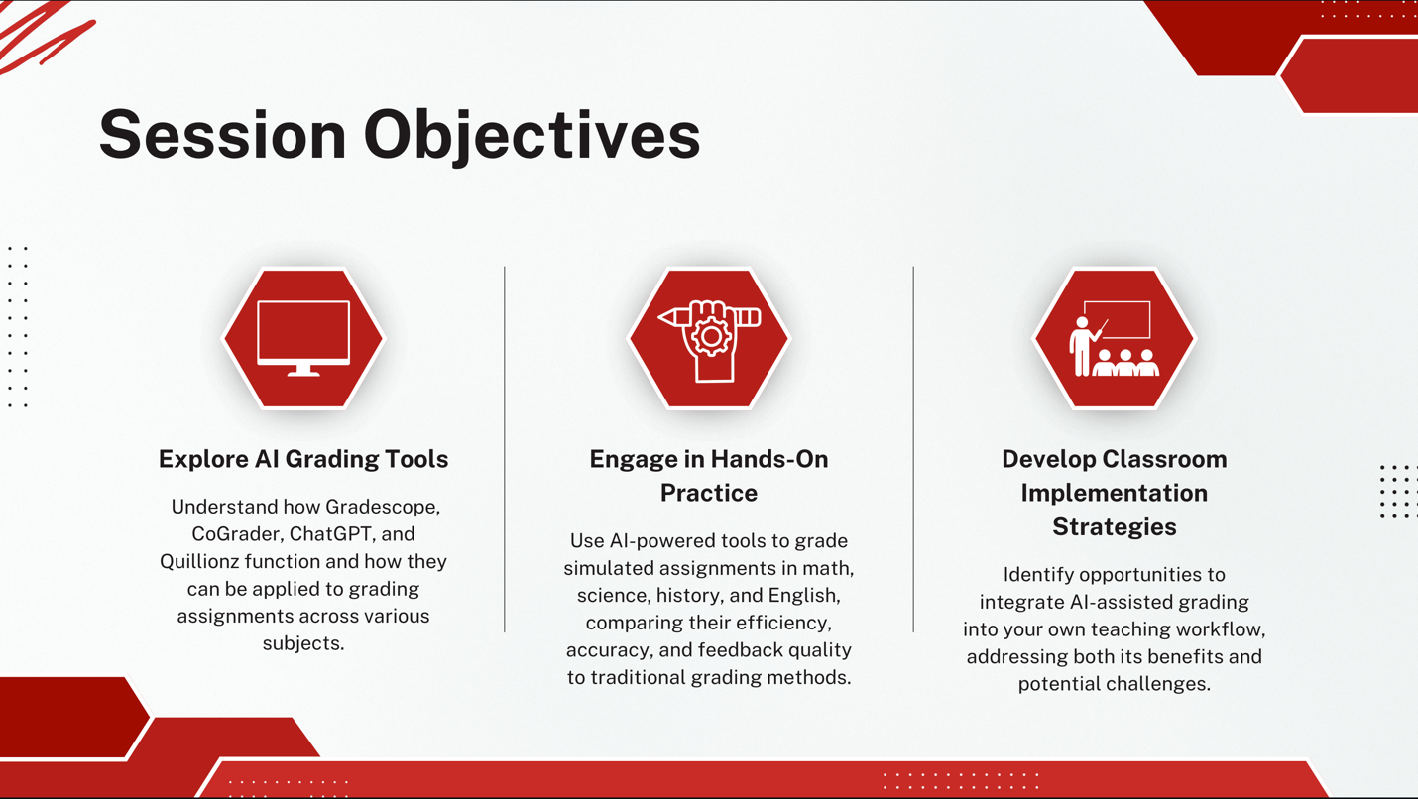
Note. This image outlined the objectives for Lesson 1, which introduced AI-assisted grading. Participants explored tools like Gradescope, CoGrader, ChatGPT, and Quillionz, engaged in hands-on practice with grading across subjects, and developed strategies to implement these tools in their own classrooms.
Teachers then engaged in a hands-on exploration of AI-driven tools, including Gradescope, MagicSchool.ai, ChatGPT, and Curipod. Working in subject-specific groups, teachers applied AI tools to real-world grading scenarios, such as assessing algebra quizzes, reviewing lab reports, evaluating historical essays, and analyzing literary responses. Independent practice allowed each teacher to experiment with AI-generated feedback, refine it based on their grading style, and reflect on its effectiveness. The lesson concluded with a group discussion, where teachers shared insights and identified best practices for integrating AI into their grading workflow.
Figure 2
Independent Practice from Lesson 1
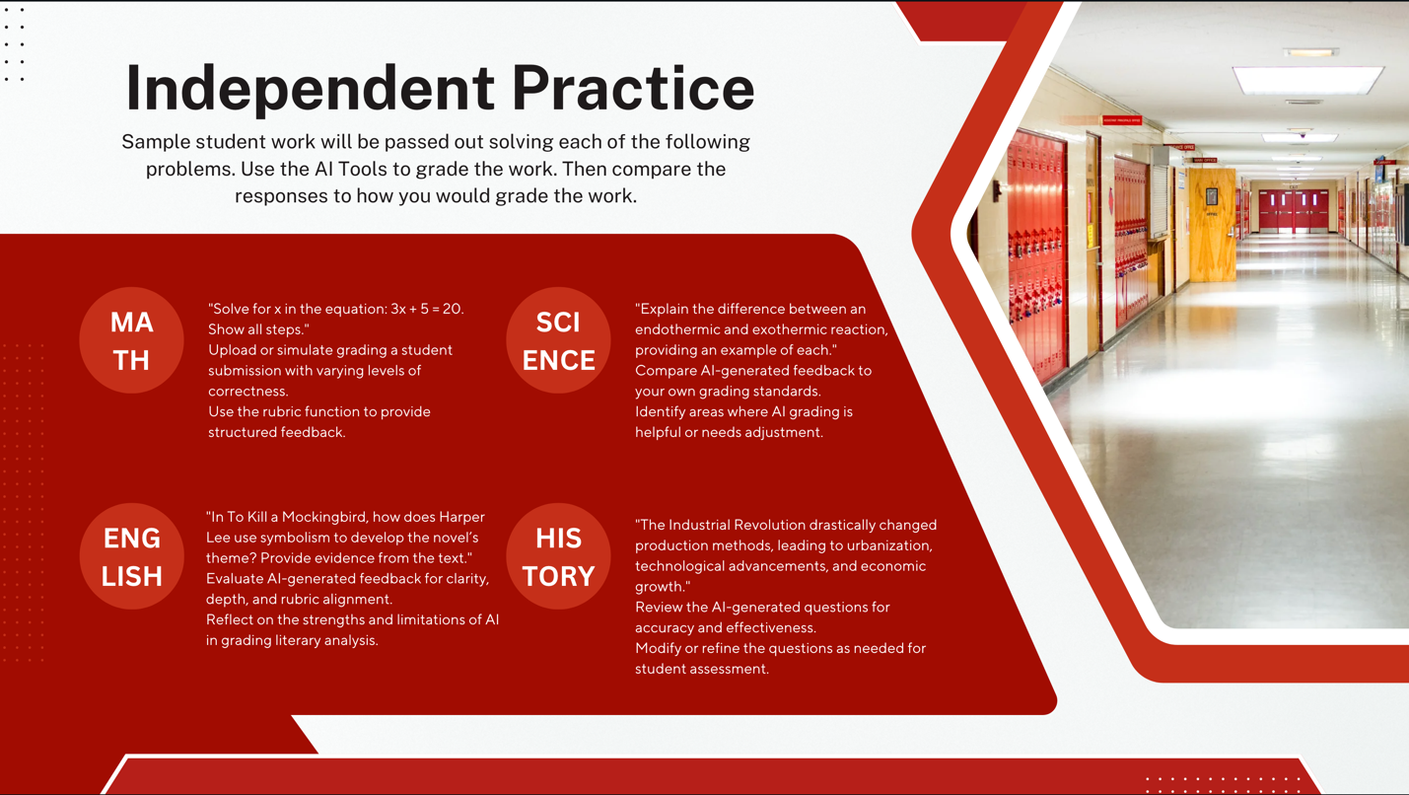
Note. Participants were given sample student responses in four subject areas, Math, Science, English, and History, and used AI tools to grade the work. Each subject included a prompt, and users were asked to analyze the AI-generated grading in comparison to their own. The activity encouraged evaluating AI feedback for clarity, accuracy, rubric alignment, and overall usefulness, while also identifying areas where human oversight or adjustment was necessary.

Lesson 2: Streamlining Lesson Planning and Resource Generation
The second lesson shifted focus to lesson planning and resource generation, tasks that often consume significant time for educators. After an introduction to the importance of efficient lesson planning, teachers explored a "why statement" outlining how AI can enhance lesson design while maintaining instructional quality. A video demonstration introduced AI-powered lesson planning tools and highlighted their ability to generate lesson structures, activities, assessments, and multimedia resources.
Figure 3
Objectives from Lesson 2
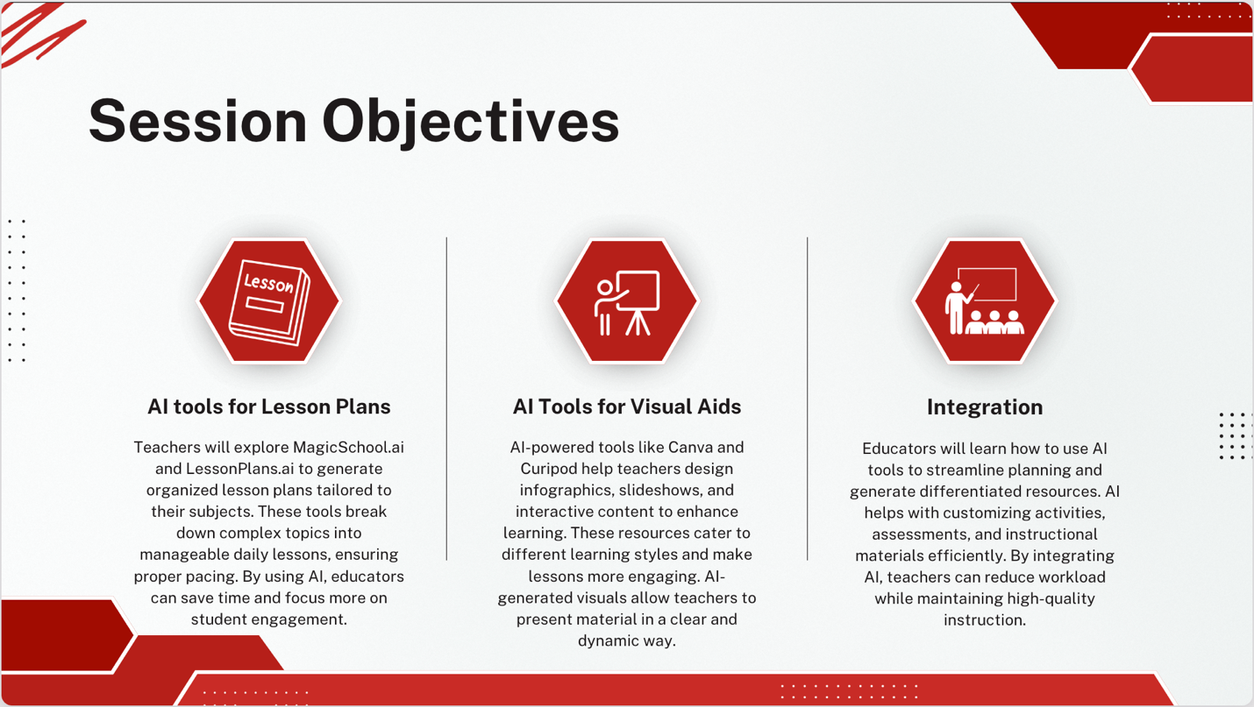
Note. This image outlines Lesson 2 objectives, focusing on using AI tools for lesson planning, visual aids, and classroom integration to enhance instruction and efficiency.
During the hands-on portion, teachers worked with MagicSchool.ai, Canva, Curipod, and LessonPlans.ai to create AI-enhanced lesson materials. Subject-specific groups designed week-long lesson plans, incorporating AI-generated worksheets, quizzes, and presentations. In independent practice, teachers customized AI-generated content to align with their teaching objectives and student needs. The session concluded with a reflection activity, where teachers discussed the advantages and limitations of AI-assisted lesson planning and shared strategies for balancing automation with personalized instruction.
Figure 4
Independent Practice from Lesson 2
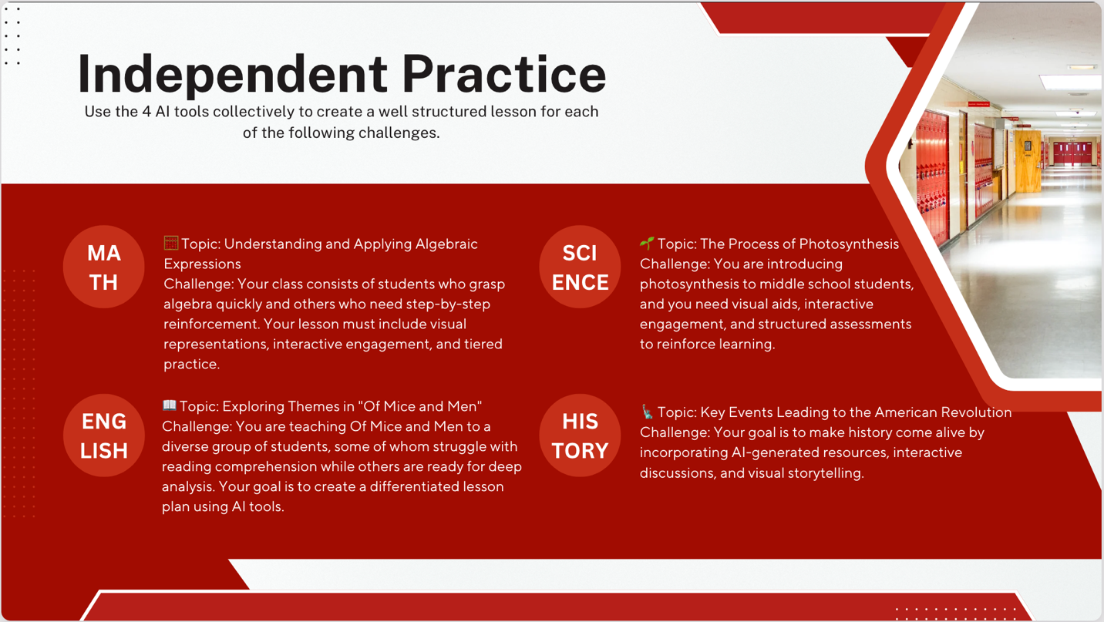
Note. This activity tasked participants with using AI tools to create differentiated, engaging lessons in math, science, English, and history based on specific classroom challenges.

Lesson 3: Developing Personalized Learning Materials for Differentiated Instruction
The third lesson addressed differentiated instruction, an essential but often complex aspect of teaching. The introduction outlined the challenges of meeting diverse student needs, followed by a "why statement" emphasizing how AI can make differentiation more manageable. A video demonstration showcased AI tools that assist in creating tiered instructional materials, adaptive assessments, and customized learning supports.
Figure 5
Objectives from Lesson 3
Note. This image outlines Lesson 3 objectives, focusing on understanding, applying, and developing AI-supported strategies to differentiate instruction for diverse learners.
Teachers then explored Khanmigo, Diffit, Quizlet, and MobyMax, using these tools to develop adaptive learning materials. In subject-specific groups, educators created tiered lesson components, such as varied reading passages, scaffolded problem sets, and differentiated practice exercises. Independent practice allowed teachers to refine AI-generated materials, tailoring them to specific learning profiles within their classrooms. The lesson concluded with a reflective discussion on how AI-supported differentiation enhances engagement and accessibility while ensuring instructional equity.
Figure 6
Independent Practice for Lesson 3
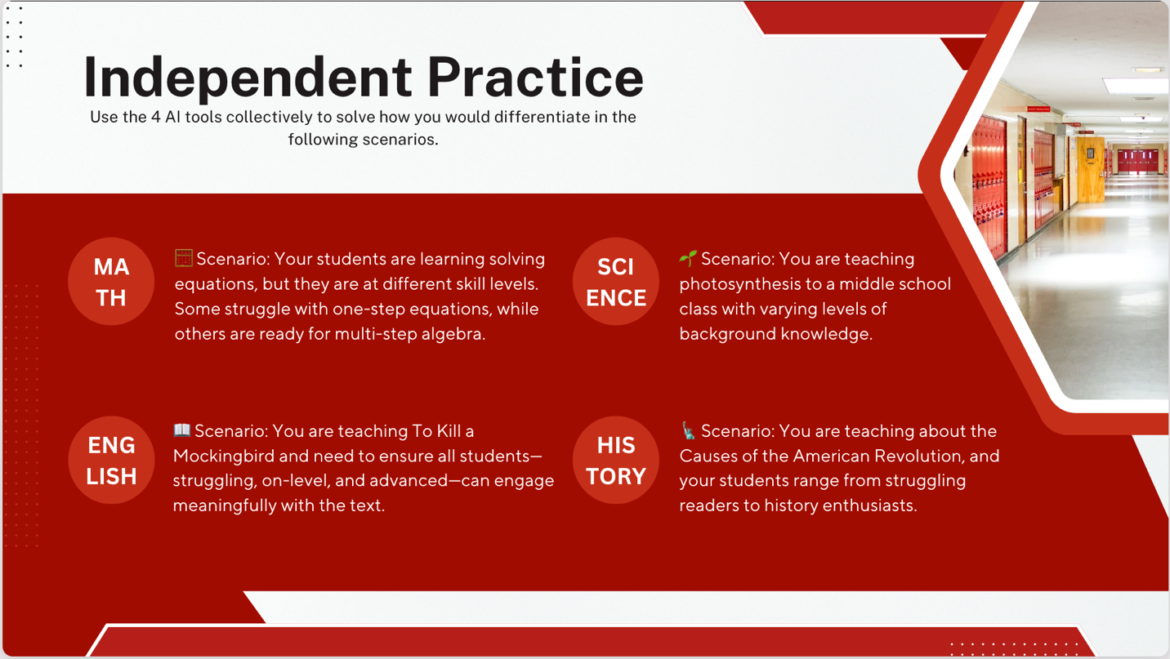
Note. This activity had participants use AI tools to design differentiated instruction for various subject scenarios, addressing students’ varying readiness and skill levels.

Lesson 4: Facilitating Parent Communication and Administrative Tasks
The fourth lesson focused on using AI for parent communication and administrative documentation, two essential but time-intensive responsibilities. The introduction framed the importance of effective communication in education and outlined the administrative burden teachers often face. A "why statement" explained how AI could streamline communication without sacrificing personalization, followed by a video showcasing AI-driven tools for drafting parent emails, progress reports, and meeting summaries.
Figure 7
Objectives for Lesson 4
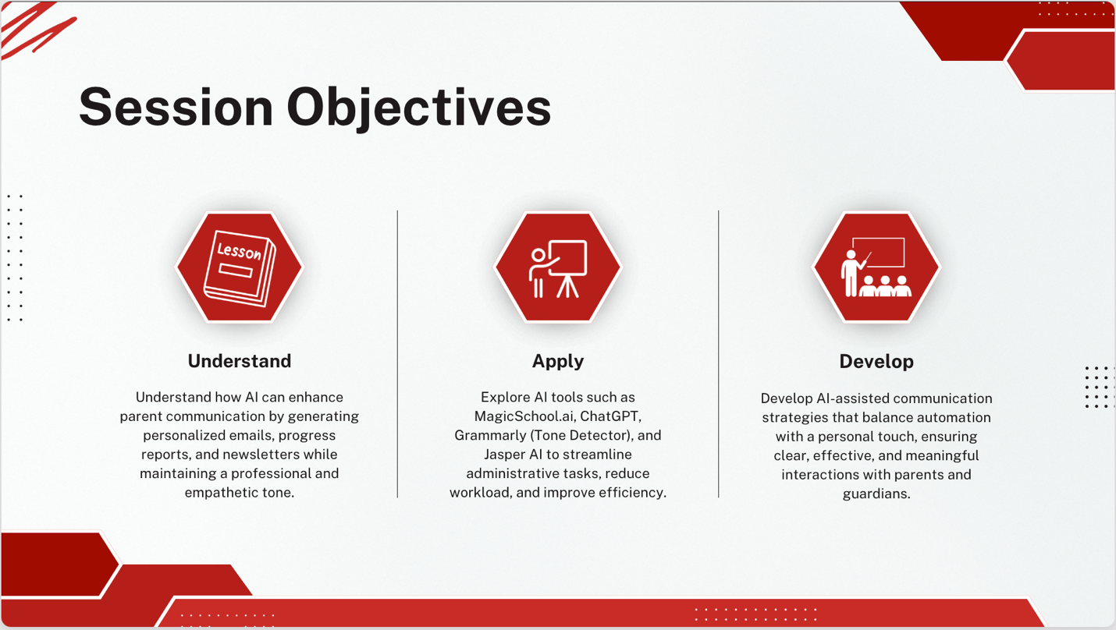
Note. This image outlines Lesson 4 objectives, focusing on using AI to enhance parent communication through personalized, efficient, and professional messaging strategies.
During the hands-on session, teachers worked with MagicSchool.ai, ChatGPT, Grammarly, and Jasper to draft communication templates for various scenarios. Teachers then practiced customizing AI-generated messages to reflect student-specific progress and feedback. Independent practice involved refining AI-assisted reports and correspondence, ensuring clarity and professionalism. A closing reflection allowed teachers to share their experiences, discuss ethical considerations, and establish strategies for using AI to maintain strong, personalized communication with parents while reducing administrative workload.
Figure 8
Independent Practice for Lesson 4
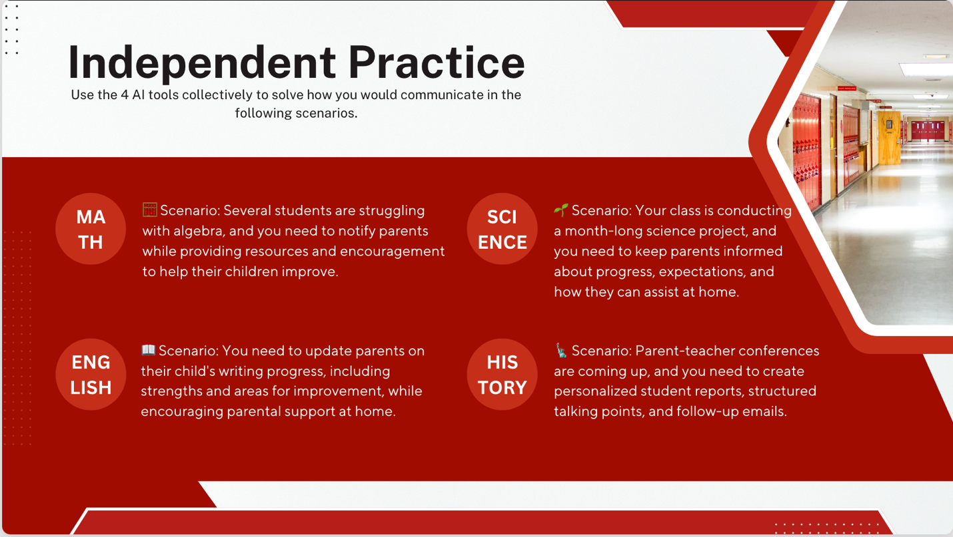
Note. This activity asked participants to use AI tools to address communication challenges across subjects, such as notifying parents about student progress, providing support resources, and preparing for conferences.

Lesson 5: Reflective Practices and Sustainable AI Integration
The final lesson emphasized the importance of reflective practice in sustaining AI integration. Teachers were introduced to the concept of continuous improvement and encouraged to evaluate their experiences with AI tools. The "why statement" framed reflection as a key strategy for ensuring meaningful, long-term AI adoption. A video showcased how educators worldwide were leveraging AI to enhance efficiency while maintaining instructional quality.
Figure 9
Objectives for Lesson 5
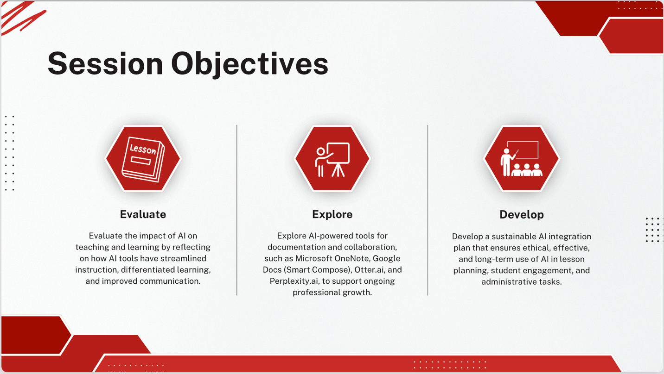
Note. This image outlines Lesson 5 objectives, which focus on evaluating AI's impact, exploring tools for collaboration and documentation, and developing a sustainable, ethical AI integration plan.
In the hands-on portion, teachers explored Microsoft OneNote, Google Docs (Smart Compose), Otter.ai, and Perplexity.ai as tools for documenting reflections and sharing best practices. Working in groups, teachers reviewed their AI-assisted lesson plans, grading strategies, and differentiation techniques, identifying successes and areas for refinement. Independent practice involved journaling experiences, setting AI integration goals, and researching further AI applications. The session concluded with a collaborative discussion on maintaining a growth mindset toward AI, ensuring sustainable and ethical use, and supporting peers in AI adoption.
Figure 10
Independent Practice for Lesson 5
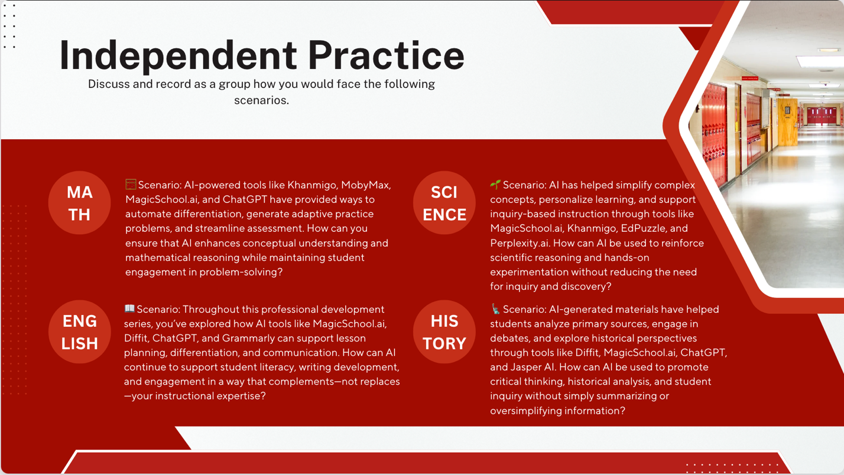
Note. This activity asked participants to reflect and discuss how they would apply AI tools in real classroom scenarios to enhance learning, support inquiry, and maintain instructional integrity across all subjects.

Sufficiency of Five Lessons
This five-lesson professional development program effectively equipped teachers with the skills and confidence to integrate generative AI into their daily routines. Each lesson was designed to address essential responsibilities such as grading, lesson planning, differentiation, and communication, ensuring AI integration was directly relevant to their work.
The program followed a structured PBL method, allowing teachers to develop confidence with AI tools through gradual skill-building. The final lesson emphasized reflection and sustainability, reinforcing AI as a long-term instructional support rather than a temporary enhancement. By providing hands-on experience and collaborative problem-solving, this program offered a practical introduction to AI that empowered educators to reduce administrative burdens and focus more on student-centered instruction. Ultimately, teachers left the program with a clear understanding of how AI can enhance efficiency, improve learning outcomes, and support innovative, engaging teaching practices.

Chapter 4: Evaluation
The purpose of this evaluation was to assess the effectiveness of the professional development program, which used problem-based learning (PBL) to teach secondary educators how to integrate generative AI tools into their instructional routines. This program aimed to equip teachers with practical skills needed to automate routine tasks, enhance instructional efficiency, and engage in innovative, student-centered teaching. The evaluation measured the program's impact on teachers’ performance, their understanding of AI tools, and their perceptions of the PBL approach in the training sessions.
Two evaluation tools were employed: data analysis of teachers' performance pre- and post-intervention and an anonymous survey capturing feedback on the effectiveness of the training and the PBL methodology.

First Evaluation
The first tool tracked teacher performance data before and after the intervention to evaluate the effectiveness of the training sessions. Performance metrics measured efficiency in completing routine teaching tasks, such as grading, lesson planning, and creating differentiated instructional materials. This data spanned all five professional development sessions and included tasks specific to each subject area: math, science, history, and English. Pre-intervention data metrics captured during the needs analysis showed how long teachers took to complete tasks without AI tools, as presented in Appendix A. Post-intervention data metrics evaluated efficiency and quality after training in AI tools such as MagicSchool.ai, ChatGPT, Canva, and Khanmigo. Additionally, it assessed the effectiveness of AI tools across the four specific subject areas, detailed in Appendix B.
First Evaluation Results
The results of the first evaluation tool can be found in Appendix C. One major takeaway from the general post-intervention survey was that a significant majority of teachers reported increased efficiency in grading, lesson planning, and administrative tasks. Tools such as MagicSchool.ai, ChatGPT, and Gradescope were consistently cited as instrumental in helping teachers save time while maintaining or even improving the quality of their instructional output. Notably, over 80% of respondents indicated they were either “Likely” or “Strongly Likely” to continue using these tools moving forward, showing that the intervention not only addressed immediate challenges but also fostered long-term adoption habits.
In the subject-specific data, math and English teachers particularly noted the effectiveness of AI in creating differentiated materials and streamlining grading. Science teachers found value in using AI to create multimedia content for labs and lessons, while social studies teachers appreciated AI’s ability to generate timelines, maps, and analytical writing prompts. Across subjects, confidence in using AI tools grew substantially, and many teachers highlighted the real-world relevance of the training provided through the PBL model.
These findings confirm that the AI-based professional development intervention was successful in reducing workload, enhancing instructional quality, and improving teachers’ confidence. More importantly, the program has laid a foundation for sustainable AI integration that supports more personalized, engaging learning environments.

Second Evaluation
The second tool was an anonymous survey that evaluated the effectiveness of the training program, the application of the PBL methodology, and the integration of generative AI tools. The survey included questions tailored to each of the five professional development sessions, focusing on the perceived impact of the tools and the value of the PBL approach. This survey can be found in Appendix D.

Second Evaluation Results
The results of the second evaluation can be found in Appendix E. Many of the teachers reported positively on the training’s practicality and relevance: 8 respondents agreed and another 8 strongly agreed that the sessions provided practical strategies for implementing AI in the classroom. Confidence levels mirrored this response, with 16 teachers indicating they felt confident or strongly confident in applying AI tools for grading, lesson planning, differentiation, and communication. Similarly, the use of PBL scenarios was rated favorably, with the same distribution, 8 agreeing and 8 strongly agreeing that the PBL approach helped them understand how to apply AI tools to real classroom problems.
The hands-on activities were well received as well, with half of respondents agreeing or strongly agreeing that the activities were valuable for practicing AI integration. Responses were evenly split in favor of future AI use, with 8 teachers saying they are likely and 8 saying they are strongly likely to continue using these tools.
Open-ended responses offered insights into the specific tools and further support needs. ChatGPT and MagicSchool.ai were each mentioned as the most valuable tools for subject-specific applications, praised for their versatility and simplicity. For future professional development, teachers requested deeper training in areas like advanced lesson design, classroom simulations, and automation of administrative tasks, indicating an appetite for continued AI learning that is closely tied to day-to-day instructional needs.

Chapter 5: Discussion and Conclusion

Summary of the Study
This study aimed to examine the effectiveness of integrating generative AI tools into secondary education through problem-based learning (PBL) strategies. The intervention focused on reducing the workload of teachers by leveraging AI for tasks such as lesson planning, grading, differentiation, and communication. Teachers participated in structured professional development sessions that introduced AI tools and guided them through real-world scenarios demonstrating their practical applications. Throughout the study, educators engaged with AI-driven platforms to streamline their workflow, enhance instructional efficiency, and provide personalized learning experiences for students.
The findings of this study indicated that AI tools had a significant impact on reducing administrative burdens, improving lesson planning efficiency, and supporting differentiated instruction. Educators reported increased confidence in using AI after participating in the intervention, and their feedback highlighted the value of structured training to maximize the benefits of these technologies. While challenges such as technical familiarity and accessibility were noted, the overall results suggested that AI integration, when properly implemented, has the potential to enhance teaching practices and improve student engagement.
Discussion
From the initial needs analysis to the final post-intervention surveys, the process confirmed what many educators already sensed: teachers are overwhelmed by repetitive tasks and eager to explore tools that can make their work more efficient and impactful. What started as a broad idea, introducing generative AI into classroom workflows, quickly evolved into a highly targeted, scaffolded learning experience shaped by real data and real needs. The feedback received from the focus groups helped shape each session to address specific concerns and priorities, ensuring that the training felt relevant and supportive rather than overwhelming.
One of the most powerful aspects of the project was watching how teachers responded to the hands-on, problem-based learning approach. Instead of simply hearing about AI tools, teachers were encouraged to try them, tweak them, and consider how they might realistically fit into their daily routines. This approach led to genuine moments of discovery, collaboration, and even excitement as educators began to see AI not as a threat or gimmick but as a practical solution to real classroom challenges. The data showed that participants not only grew in confidence and efficiency but also expressed interest in continuing to learn about AI and how it can evolve with their teaching needs.
Overall, this project underscored the importance of intentional, well-supported professional development that respects teachers’ time and meets them where they are. The response to the sessions validated the time spent designing them, and the results suggest that when given the right tools and the right structure, educators are more than willing to embrace innovation. This experience has been a clear reminder that effective PD isn’t about pushing the latest tech trend—it’s about empowering teachers to do their jobs better and with greater joy.

Limitations of the Study
Despite the promising findings, this study had several limitations. One of the primary challenges was the variability in teachers’ familiarity with AI technology. While the professional development sessions provided foundational training, some educators required more time to develop confidence and proficiency in using AI tools effectively. Future studies could explore extended training programs with follow-up support to ensure long-term adoption.
Another limitation was the reliance on self-reported data from teachers, which may introduce bias into the findings. While surveys and reflections provided valuable insights, incorporating objective measures such as classroom observations or AI usage analytics could strengthen the validity of future research. Additionally, the study was conducted within a specific school setting, limiting the generalizability of results to other educational contexts. Expanding the sample size and including schools with different demographics could offer a broader perspective on AI’s impact in education.

Implications for Future Research and Practice
The findings of this study highlight several implications for future research and practice. First, expanding AI training for educators is crucial to ensure widespread adoption and effective implementation. Schools and districts should consider integrating AI-focused professional development into their regular training programs to support teachers in leveraging technology for instructional purposes.
Second, further research is needed to examine the long-term impact of AI integration on both teachers and students. Studies that track AI usage over multiple academic years could provide deeper insights into its sustainability and effectiveness in improving educational outcomes. Additionally, investigating student perspectives on AI-assisted instruction could offer valuable information on how these tools influence engagement, motivation, and learning retention.
Finally, ethical considerations surrounding AI use in education must be explored in greater depth. While AI offers significant advantages in terms of efficiency and differentiation, concerns related to data privacy, bias in AI-generated content, and the role of human oversight remain important areas for discussion. Future research should address these concerns and develop best practices to ensure that AI integration aligns with ethical and pedagogical standards.

Conclusion
This study demonstrated that generative AI tools have the potential to transform teaching practices by reducing administrative burdens, enhancing lesson planning, and supporting differentiated instruction. The intervention provided educators with hands-on experience in integrating AI into their workflow, leading to increased efficiency and improved instructional design. While challenges such as technical familiarity and ethical considerations must be addressed, the overall findings suggest that AI, when implemented thoughtfully, can be an asset in modern classrooms.
Moving forward, continued research, training, and policy development will be essential to maximize the benefits of AI in education while ensuring that it is used responsibly and effectively. As technology continues to evolve, educators must remain adaptable and open to new innovations that enhance student learning and streamline teaching practices. The insights gained from this study contribute to the growing body of knowledge on AI in education and provide a foundation for further exploration and implementation of AI-driven instructional strategies.

References:
Hammond, M. (2020). What is an ‘educational’ use of generative AI? British Journal of Educational Technology, 51(2), 411-422.
Hashem, R., Ali, N., El Zein, F., Fidalgo, P., & Abu Khurma, O. (2024). AI to the rescue: Exploring the potential of ChatGPT as a teacher ally for workload relief and burnout prevention. Research and Practice in Technology Enhanced Learning, 19, 023. https://doi.org/10.58459/rptel.2024.19023
Hmelo-Silver, C. E. (2004). Problem-based learning: What and how do students learn? Educational Psychology Review, 16(3), 235-266. https://doi.org/10.1023/B:EDPR.0000034022.16470.f3
Kaplan-Rakowski, R., Grotewold, K., Hartwick, P., & Papin, K. (2023). Generative AI and teachers' perspectives on its implementation in education. Journal of Interactive Learning Research, 34(2), 313-338.
Koukopoulos, Z., & Koukopoulos, D. (2020). AI in education: Best practices and future prospects for integrating AI into teaching and learning processes. Journal of Educational Technology & Society, 23(3), 20-29.
Luckin, R., Holmes, W., Griffiths, M., & Forcier, L. B. (2016). Intelligence unleashed: An argument for AI in education. British Journal of Educational Technology, 47(6), 2174-2188.
Savery, J. R. (2015). Overview of problem-based learning: Definitions and distinctions. In Essential Readings in Problem-Based Learning (pp. 9-14).
Thorndahl, K. L., & Stentoft, D. (2020). Problem-based learning and critical thinking. Interdisciplinary Journal of Problem-Based Learning, 14(1). https://doi.org/10.7771/1541-5015.1845

Appendix A.
Needs Analysis Survey
Purpose: To establish a baseline of teacher performance metrics prior to the integration of generative AI tools. This data captures teachers’ efficiency in completing routine tasks such as grading, lesson planning, and creating instructional materials without AI tools. The pre-intervention data will serve as a comparison point to evaluate the effectiveness of the professional development program.
Generative AI use by secondary educators:
- How familiar are you with generative AI tools (e.g., ChatGPT, Google Gemini, MagicSchool.ai, etc.) and their potential uses in education?
Not familiar at all | Somewhat familiar | Moderately familiar | Very familiar | Extremely familiar

- Among the tasks listed below, how long do you spend typically on each one weekly?
Lesson planning | Creating instructional materials | Managing administrative tasks | Communicating with parents | Grading assignments

- How confident do you feel about using AI tools to assist with non-instructional tasks (example: lesson planning, resource creation)?
Not confident at all | Somewhat confident | Moderately confident | Very confident | Extremely confident

- What barriers or challenges prevent you from using AI tools in your daily work? Select all that apply and write a brief description of why you feel these challenges exist.

Lack of knowledge | Time constraints | Concerns about effectiveness | Technology Aptitude | Don’t want to learn something new.

- How interested would you be in participating in professional development sessions focused on integrating AI tools into your teaching practices?
Not interested at all | Somewhat interested | Moderately interested | Very interested | Extremely interested

- In your daily work, do you have any ideas or insights as to where you can incorporate generative AI?
(Open Ended)
- What support or resources would you need to feel comfortable integrating AI tools into your teaching practices? Examples: training workshops, instructional guides, peer mentoring, online forums and communities, weekly instructional emails, Zoom/online conferencing.
(Open Ended)

Appendix B.

Post-Intervention Survey
Purpose: This survey evaluates changes in teacher performance metrics after the implementation of AI tools introduced during the professional development sessions. It measures improvements in efficiency, instructional quality, differentiation, parent communication, and sustainable AI integration. The results will be compared with pre-intervention data to assess the overall impact of the training program.

General Survey Questions
Category | Survey Question
Grading and Feedback | Did the use of AI tools (Gradescope, ChatGPT, MagicSchool.ai) improve your efficiency in grading and providing feedback? | Strongly Disagree | Disagree | Neutral | Agree | Strongly Agree
 | How confident do you feel in using these tools to generate consistent and personalized feedback for students? | Unconfident | Somewhat Confident | Neutral | Confident | Strongly Confident
Lesson Planning and Resource Creation | Do you think tools like MagicSchool.ai, Piktochart, Curipod, and LessonPlan.ai reduced the time required to plan lessons and create materials? | Strongly Disagree | Disagree | Neutral | Agree | Strongly Agree
 | Were the materials generated by these tools (e.g., quizzes, worksheets, slides) of sufficient quality to meet your instructional needs? | Yes | No
 | How likely are you to continue using these AI tools for lesson planning? | Very Unlikely | Unlikely | Neutral | Likely | Strongly Likely
Differentiation and Personalization | Did AI tools (MagicSchool.ai, Khanmigo, Diffit, MobyMax) help you create differentiated instructional materials that meet the needs of diverse learners? | Strongly Disagree | Disagree | Neutral | Agree | Strongly Agree
 | How effective were these tools in tailoring content to individual student skill levels? | Very Ineffective | Ineffective | Neutral | Effective | Very Effective
Parent Communication and Administrative Tasks | Did AI tools like Jasper, Grammarly, and ChatGPT streamline your administrative responsibilities (e.g., parent communication, progress reports)? | Strongly Disagree | Disagree | Neutral | Agree | Strongly Agree
 | How confident do you feel in using these tools for routine administrative tasks? | Unconfident | Somewhat Confident | Neutral | Confident | Strongly Confident
Long-Term AI Integration | Do you feel prepared to integrate AI tools into your teaching practice sustainably? | Strongly Disagree | Disagree | Neutral | Agree | Strongly Agree
 | What challenges do you anticipate in using AI tools long-term? | (Open-Ended Response)

Subject-Specific Questions
(Only answer based on your subject area.)
Category | Survey Question
Math Teachers | Did AI tools (MagicSchool.ai, Khanmigo, MobyMax) help you create differentiated math practice problems? | Strongly Disagree | Disagree | Neutral | Agree | Strongly Agree
 | How effective were AI tools in streamlining the grading of math quizzes and identifying common errors? | Very Ineffective | Ineffective | Neutral | Effective | Very Effective
Science Teachers | Did AI tools (MagicSchool.ai, ChatGPT, Khanmigo) improve your ability to create lab reports, lesson materials, or interactive activities? | Strongly Disagree | Disagree | Neutral | Agree | Strongly Agree
 | Were AI tools effective in generating engaging multimedia content (videos, diagrams) to support science instruction? | Strongly Disagree | Disagree | Neutral | Agree | Strongly Agree
Social Studies Teachers | Did AI tools (MagicSchool.ai, Canva, ChatGPT) help you create resources such as timelines, maps, or primary source analyses? | Strongly Disagree | Disagree | Neutral | Agree | Strongly Agree
 | How effective were tools like ChatGPT in creating discussion prompts and essay feedback for historical analysis? | Very Ineffective | Ineffective | Neutral | Effective | Very Effective
English Teachers | Did AI tools (MagicSchool.ai, ChatGPT, Diffit) help you create differentiated reading passages or analysis questions for literary works? | Strongly Disagree | Disagree | Neutral | Agree | Strongly Agree
 | How useful were AI tools in generating feedback for student essays and literary analyses? | Very Ineffective | Ineffective | Neutral | Effective | Very Effective

Appendix C.
First Evaluation Survey Results

Teacher | Did the use of AI tools (Gradescope, ChatGPT, MagicSchool.ai) improve your efficiency in grading and providing feedback? | How confident do you feel in using these tools to generate consistent and personalized feedback for students? | Do you think tools like MagicSchool.ai, Piktochart, Curipod, and LessonPlan.ai reduced the time required to plan lessons and create materials? | Were the materials generated by these tools (e.g., quizzes, worksheets, slides) of sufficient quality to meet your instructional needs? | How likely are you to continue using these AI tools for lesson planning? | Did AI tools (MagicSchool.ai, Khanmigo, Diffit, MobyMax) help you create differentiated instructional materials that meet the needs of diverse learners? | How effective were these tools in tailoring content to individual student skill levels? | Did AI tools like Jasper, Grammarly, and ChatGPT streamline your administrative responsibilities (e.g., parent communication, progress reports)? | How confident do you feel in using these tools for routine administrative tasks? | Do you feel prepared to integrate AI tools into your teaching practice sustainably? | What challenges do you anticipate in using AI tools long-term?
1 | Agree | Confident | Agree | Yes | Likely | Agree | Effective | Agree | Confident | Agree | Keeping up with constant updates and new tools.
2 | Strongly Agree | Strongly Confident | Strongly Agree | Yes | Strongly Likely | Strongly Agree | Very Effective | Strongly Agree | Strongly Confident | Strongly Agree | Ensuring student data privacy and security.
3 | Neutral | Neutral | Neutral | Yes | Neutral | Neutral | Neutral | Neutral | Neutral | Neutral | Over-reliance on AI reducing teacher autonomy.
4 | Disagree | Somewhat Confident | Disagree | No | Unlikely | Disagree | Ineffective | Disagree | Somewhat Confident | Disagree | Inconsistent output quality from AI tools.
5 | Agree | Confident | Agree | Yes | Likely | Agree | Effective | Agree | Confident | Agree | Balancing AI use with traditional methods.
6 | Agree | Confident | Agree | Yes | Likely | Agree | Effective | Agree | Confident | Agree | Time required to train staff on new tools.
7 | Strongly Agree | Strongly Confident | Strongly Agree | Yes | Strongly Likely | Strongly Agree | Very Effective | Strongly Agree | Strongly Confident | Strongly Agree | Integrating AI seamlessly into current curriculum.
8 | Neutral | Neutral | Neutral | No | Neutral | Neutral | Neutral | Neutral | Neutral | Neutral | Dependence on internet access and tech infrastructure.
9 | Agree | Confident | Agree | Yes | Likely | Agree | Effective | Agree | Confident | Agree | Students potentially misusing AI tools.
10 | Strongly Agree | Strongly Confident | Strongly Agree | Yes | Strongly Likely | Strongly Agree | Very Effective | Strongly Agree | Strongly Confident | Strongly Agree | Difficulty maintaining a human touch in teaching.
11 | Neutral | Neutral | Neutral | Yes | Neutral | Neutral | Neutral | Neutral | Neutral | Neutral | Budget limitations for premium AI tools.
12 | Disagree | Somewhat Confident | Disagree | No | Unlikely | Disagree | Ineffective | Disagree | Somewhat Confident | Disagree | Skepticism from parents or administrators.
13 | Agree | Confident | Agree | Yes | Likely | Agree | Effective | Agree | Confident | Agree | Making time to explore full capabilities of AI.
14 | Agree | Confident | Agree | Yes | Likely | Agree | Effective | Agree | Confident | Agree | Ensuring equity for students without tech access.
15 | Neutral | Neutral | Neutral | Yes | Neutral | Neutral | Neutral | Neutral | Neutral | Neutral | Staying informed about ethical AI usage.
16 | Strongly Disagree | Unconfident | Strongly Disagree | No | Very Unlikely | Strongly Disagree | Very Ineffective | Strongly Disagree | Unconfident | Strongly Disagree | Difficulty trusting AI to be accurate consistently.
17 | Agree | Confident | Agree | Yes | Likely | Agree | Effective | Agree | Confident | Agree | Teachers losing creative input to automation.
18 | Strongly Agree | Strongly Confident | Strongly Agree | Yes | Strongly Likely | Strongly Agree | Very Effective | Strongly Agree | Strongly Confident | Strongly Agree | Varying comfort levels among staff with technology.
19 | Disagree | Somewhat Confident | Disagree | No | Unlikely | Disagree | Ineffective | Disagree | Somewhat Confident | Disagree | Monitoring student understanding when AI assists.
20 | Neutral | Neutral | Neutral | Yes | Neutral | Neutral | Neutral | Neutral | Neutral | Neutral | Risk of AI reinforcing bias in content.
21 | Agree | Confident | Agree | Yes | Likely | Agree | Effective | Agree | Confident | Agree | Managing multiple platforms and logins.
22 | Strongly Agree | Strongly Confident | Strongly Agree | Yes | Strongly Likely | Strongly Agree | Very Effective | Strongly Agree | Strongly Confident | Strongly Agree | Ensuring AI aligns with state standards.
23 | Neutral | Neutral | Neutral | Yes | Neutral | Neutral | Neutral | Neutral | Neutral | Neutral | Confusion over which AI tools are most effective.
24 | Agree | Confident | Agree | Yes | Likely | Agree | Effective | Agree | Confident | Agree | Limited technical support for troubleshooting.
25 | Strongly Agree | Strongly Confident | Strongly Agree | Yes | Strongly Likely | Strongly Agree | Very Effective | Strongly Agree | Strongly Confident | Strongly Agree | Fear of AI replacing teaching roles.
26 | Disagree | Somewhat Confident | Disagree | No | Unlikely | Disagree | Ineffective | Disagree | Somewhat Confident | Disagree | Student overdependence on AI for tasks.
27 | Neutral | Neutral | Neutral | Yes | Neutral | Neutral | Neutral | Neutral | Neutral | Neutral | Difficulty adapting to frequent tool changes.
28 | Agree | Confident | Agree | Yes | Likely | Agree | Effective | Agree | Confident | Agree | Lack of consistent professional development.
29 | Agree | Confident | Agree | Yes | Likely | Agree | Effective | Agree | Confident | Agree | Integrating AI into hands-on or lab-based courses.
30 | Strongly Agree | Strongly Confident | Strongly Agree | Yes | Strongly Likely | Strongly Agree | Very Effective | Strongly Agree | Strongly Confident | Strongly Agree | Making sure AI tools reflect diverse learning needs.

Appendix D.

Survey on the Effectiveness of the Intervention

Purpose: This survey gathers qualitative feedback on the professional development program, focusing on the relevance of real-world AI applications for teachers. The results will help identify strengths and areas for improvement.

Survey Questions
Category | Survey Question
Effectiveness of AI Training | Did this training provide practical strategies for implementing AI in your classroom? | Strongly Disagree | Disagree | Neutral | Agree | Strongly Agree
 | How confident do you feel in applying AI tools to grading, lesson planning, differentiation, and communication? | Unconfident | Somewhat Confident | Neutral | Confident | Strongly Confident
Problem-Based Learning (PBL) Scenarios | Did the PBL approach (e.g., real-life classroom scenarios) help you understand how to apply AI tools to solve teaching challenges? | Strongly Disagree | Disagree | Neutral | Agree | Strongly Agree
 | How engaging and relevant were the PBL scenarios to your specific teaching needs? | Strongly Irrelevant | Irrelevant | Neutral | Relevant | Strongly Relevant
Collaboration and Critical Thinking | How effectively did the workshops encourage collaboration and critical thinking in applying AI tools? | Very Ineffective | Ineffective | Neutral | Effective | Very Effective
 | Were the hands-on activities valuable in helping you practice AI integration? | Strongly Disagree | Disagree | Neutral | Agree | Strongly Agree
Long-Term AI Implementation | How likely are you to continue using AI tools in your teaching practice? | Very Unlikely | Unlikely | Neutral | Likely | Strongly Likely
 | What AI tool do you see as the most valuable for your subject area, and why? | (Open-Ended Response)
 | What additional AI-related professional development would you find useful? | (Open-Ended Response)

Appendix E.
Second Evaluation Survey Results

Teacher | Did this training provide practical strategies for implementing AI in your classroom? | How confident do you feel in applying AI tools to grading, lesson planning, differentiation, and communication? | Did the PBL approach (e.g., real-life classroom scenarios) help you understand how to apply AI tools to solve teaching challenges? | How engaging and relevant were the PBL scenarios to your specific teaching needs? | How effectively did the workshops encourage collaboration and critical thinking in applying AI tools? | Were the hands-on activities valuable in helping you practice AI integration? | How likely are you to continue using AI tools in your teaching practice? | What AI tool do you see as the most valuable for your subject area, and why? | What additional AI-related professional development would you find useful?
1 | Agree | Confident | Agree | Relevant | Effective | Agree | Likely | ChatGPT - Versatile across tasks | Advanced lesson design with AI
2 | Strongly Agree | Strongly Confident | Strongly Agree | Strongly Relevant | Very Effective | Strongly Agree | Strongly Likely | MagicSchool - Simple and intuitive | Real-life classroom simulations
3 | Neutral | Neutral | Neutral | Neutral | Neutral | Neutral | Neutral | Diffit - Good for differentiation | More on student data privacy
4 | Disagree | Somewhat Confident | Disagree | Irrelevant | Ineffective | Disagree | Unlikely | Khanmigo - Useful but limited | Beginner AI workshops
5 | Agree | Confident | Agree | Relevant | Effective | Agree | Likely | MobyMax - Great for remediation | Assessment building with AI
6 | Strongly Agree | Strongly Confident | Strongly Agree | Strongly Relevant | Very Effective | Strongly Agree | Strongly Likely | MagicSchool - Easy to use | AI for project-based learning
7 | Neutral | Neutral | Neutral | Neutral | Neutral | Neutral | Neutral | Curipod - Great for engagement | Customizing AI tools by subject
8 | Disagree | Somewhat Confident | Disagree | Irrelevant | Ineffective | Disagree | Unlikely | Grammarly - Helpful for writing | Troubleshooting AI issues
9 | Agree | Confident | Agree | Relevant | Effective | Agree | Likely | ChatGPT - Helps generate writing prompts | Peer collaboration with AI
10 | Strongly Agree | Strongly Confident | Strongly Agree | Strongly Relevant | Very Effective | Strongly Agree | Strongly Likely | Canva - Visuals and slides made easy | Visual design integration
11 | Neutral | Neutral | Neutral | Neutral | Neutral | Neutral | Neutral | Curipod - Interactivity is good | Lesson pacing with AI
12 | Disagree | Somewhat Confident | Disagree | Irrelevant | Ineffective | Disagree | Unlikely | Jasper - Email writing is fast | Writing communication with AI
13 | Agree | Confident | Agree | Relevant | Effective | Agree | Likely | MagicSchool - Saves planning time | Feedback generation training
14 | Strongly Agree | Strongly Confident | Strongly Agree | Strongly Relevant | Very Effective | Strongly Agree | Strongly Likely | ChatGPT - Versatile in content | Embedding AI into curriculum
15 | Neutral | Neutral | Neutral | Neutral | Neutral | Neutral | Neutral | Canva - Visual content is useful | AI in interdisciplinary teaching
16 | Disagree | Somewhat Confident | Disagree | Irrelevant | Ineffective | Disagree | Unlikely | Khanmigo - Works for math support | AI safety and ethics
17 | Agree | Confident | Agree | Relevant | Effective | Agree | Likely | Diffit - Great for scaffolding | Tailoring content to skill levels
18 | Strongly Agree | Strongly Confident | Strongly Agree | Strongly Relevant | Very Effective | Strongly Agree | Strongly Likely | MagicSchool - Reliable toolset | Classroom AI case studies
19 | Neutral | Neutral | Neutral | Neutral | Neutral | Neutral | Neutral | MobyMax - Student skill tracking | Navigating multiple AI tools
20 | Disagree | Somewhat Confident | Disagree | Irrelevant | Ineffective | Disagree | Unlikely | Grammarly - Editing help | Managing AI expectations
21 | Agree | Confident | Agree | Relevant | Effective | Agree | Likely | Canva - Easy resource design | Designing AI-enhanced rubrics
22 | Strongly Agree | Strongly Confident | Strongly Agree | Strongly Relevant | Very Effective | Strongly Agree | Strongly Likely | ChatGPT - Versatile feedback generator | Best practices from other teachers
23 | Neutral | Neutral | Neutral | Neutral | Neutral | Neutral | Neutral | MagicSchool - Convenient UI | Interactive AI demonstrations
24 | Disagree | Somewhat Confident | Disagree | Irrelevant | Ineffective | Disagree | Unlikely | Jasper - Makes admin easier | Automation for reports
25 | Agree | Confident | Agree | Relevant | Effective | Agree | Likely | Diffit - Helps reach all learners | Integrating AI with state standards
26 | Strongly Agree | Strongly Confident | Strongly Agree | Strongly Relevant | Very Effective | Strongly Agree | Strongly Likely | Canva - Efficient presentation tool | AI for ELL support
27 | Neutral | Neutral | Neutral | Neutral | Neutral | Neutral | Neutral | MobyMax - Works for quick review | Finding trusted AI tools
28 | Disagree | Somewhat Confident | Disagree | Irrelevant | Ineffective | Disagree | Unlikely | Grammarly - Simplifies grammar lessons | Admin task automation workshops
29 | Agree | Confident | Agree | Relevant | Effective | Agree | Likely | Curipod - Drives classroom engagement | Live demo with student data
30 | Strongly Agree | Strongly Confident | Strongly Agree | Strongly Relevant | Very Effective | Strongly Agree | Strongly Likely | ChatGPT - Streamlines feedback and ideas | Subject-specific AI applications

